**DIFOT**

DIFOT stands for Delivery In Full On Time. It is applied to Sales orders and Transfer orders. There is a custom body checkbox field **DELIVERED IN FULL ON TIME (AU)** on Sales Orders and Transfer Order. When the DIFOT is passed, this field will be automatically checked.

In the case of Sales Orders and Transfer Order, there will be a due date for each order. If all the items are fully fulfilled on or before the due date, then that order will be a DIFOT Pass. Ie; **DELIVERED IN FULL ON TIME (AU)** field on the Sales Order/ Transfer Order will be checked.

The following status will pass the DIFOT in the case of Sales Orders.

1. **Pending Billing:** If the order is in Pending Billing status, ie; if all the items are fulfilled and ready for billing on or before the due date, such orders will be a DIFOT Pass
2. **Billed:** If the order is fulfilled and it is billed, such orders also will be a DIFOT Pass.

The following status will make a Transfer Order DIFOT Pass.

1. **Pending Receipt:** If the Transfer Order is in Pending Receipt, ie; if all the items are fulfilled and ready for the transfer, such TO will be a DIFOT Pass
2. **Received:** If the Transfer Order is fulfilled and transferred, such orders will be a DIFOT Pass

An order is DIFOT Pass means, the **DELIVERED IN FULL ON TIME (AU)** field on the Sales Order/ Transfer Order will be checked. Otherwise, it will be unchecked.

Likewise, if any of the items of the order are not fulfilled (Partially Fulfilled), then also that Order is not a DIFOT pass.

The difot operations are currently executing using workflows for both Sales orders and Transfer orders. There are separate searches used as a filter in these workflows.

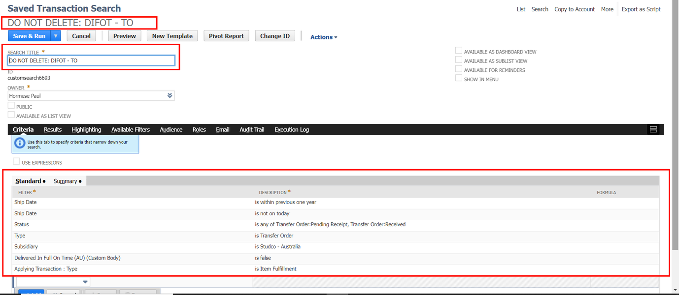

[Saved Transaction Search - NetSuite (Studco - Australia)](https://3381659.app.netsuite.com/app/common/search/search.nl?cu=T&e=T&id=973) (SO)

[Workflow - NetSuite (Studco - Australia)](https://3381659.app.netsuite.com/app/common/workflow/setup/nextgen/workflowdesktop.nl?id=46&e=T#) (SO)

[Saved Transaction Search - NetSuite (Studco - Australia)](https://3381659.app.netsuite.com/app/common/search/search.nl?cu=T&e=T&id=6693) (TO)

[Workflow - NetSuite (Studco - Australia)](https://3381659.app.netsuite.com/app/common/workflow/setup/nextgen/workflowdesktop.nl?id=132&e=T#) (TO)

**WO- DIFOT: Auto Populating Production End Date in a Work Order**

This section summarizes the setup of auto-populating the Production End Date of Work Order that is created from a Sales Order. Users can specify the Production End date in Sales Order’s Line wise. The Date entered by the user in the Sales Order Item line will be populated in its Work Orders Created.

We’ve created a custom transaction line field **WO-Production End Date** in the sales order, that contains the production end date of Work Order. This value will be auto populated in the related Work Order of a sales order. Work Orders will be created for each items on a sales order only if the item is an assembly item. So, each assembly item will have one Work order.

When the user provide WO-Production End date in the sales order item lines, each values will be set to the Production End date of each line’s corresponding Work Order.

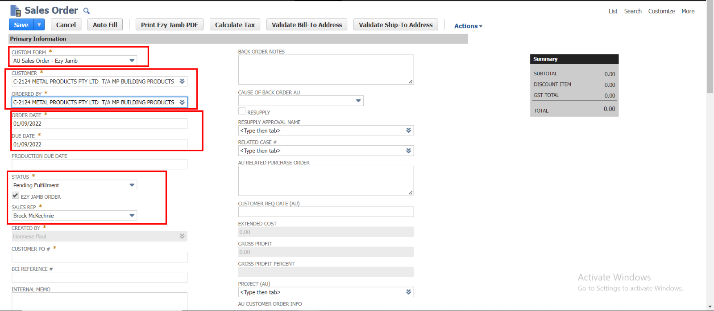  
Order date, Due date, Status, and Sales Rep values will be automatically populated.

Please Note that to create Work Orders, provide **Assembly Items**

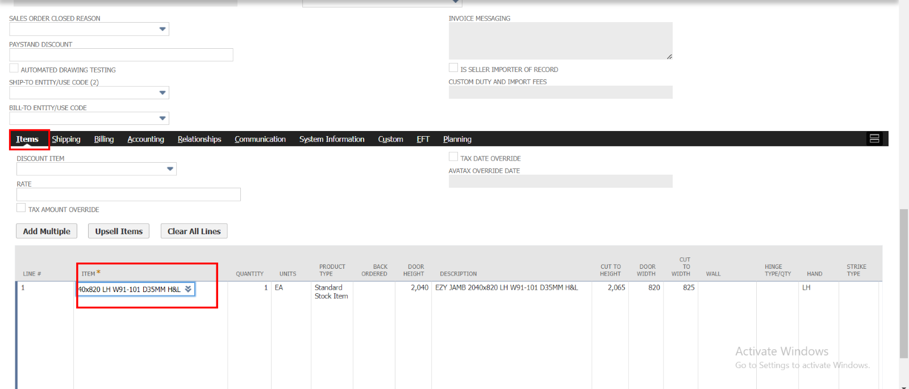

Also Provide Date for the field **WO-Production End date**

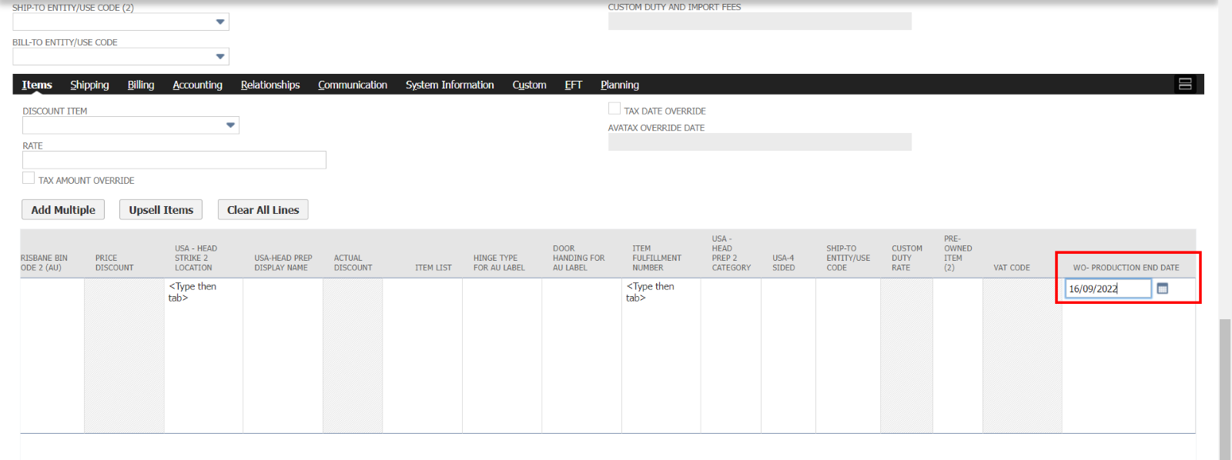

Save the Record. It will redirect to another page that contains the details of Sales Order and Work orders created

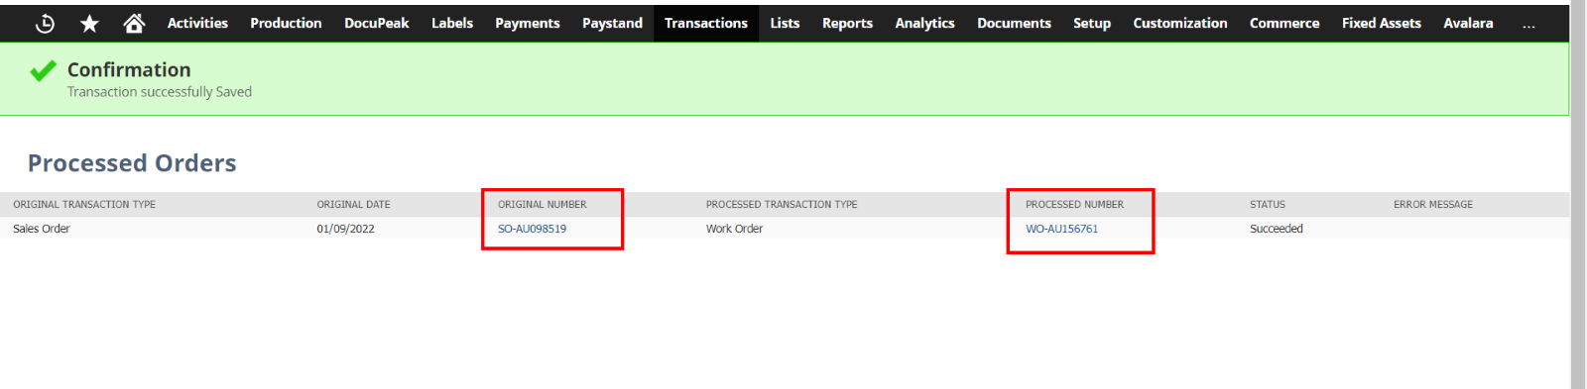

Click on the links of both Sales Order and Work orders. The Date provided in the Sales Order’s Item line field will be the Production End Date.

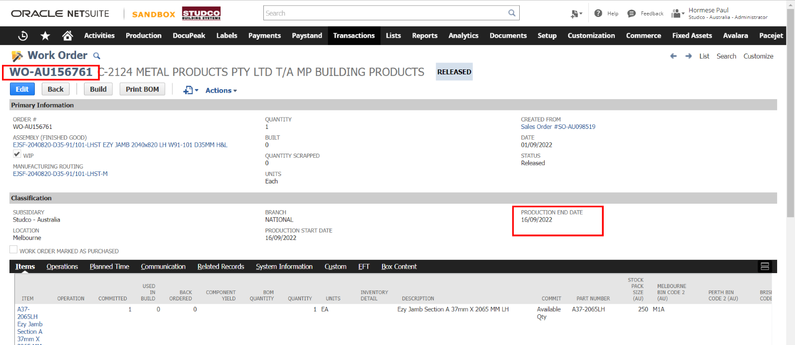  
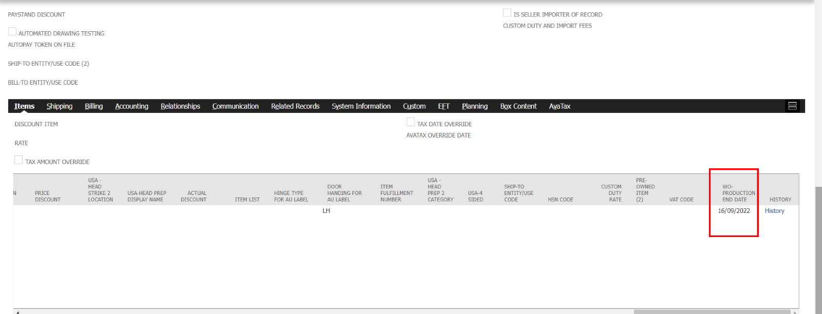  
The process will be executed irrespective of all forms of the orders. Item lines that can be entered on a Sales Order are 30. If more than 33 lines are added then a Script Usage error will occur. We’ve not considered the Rescheduling Process yet. This section is currently deployed in SB only.

**Freezing Header**

There was a requirement for the client that was, for both Sales Orders and Quotes. We’ve done that requirement. Following is the link to the script for this requirement.

[JJ UE Freezed Header SBS-127](https://3381659.app.netsuite.com/app/common/scripting/script.nl?id=1257)